



Abstract

Performance Evaluation 62 (2005) 193–209

Scalability of routing methods in ad hoc networks
Valery Naumov∗, Thomas Gross

ETH Zurich, 8093 Zurich, Switzerland
Available online 10 August 2005

In an ad hoc network each host (node) participates in routing packets. Ad hoc networks based on 802.11 WLAN
technology have been the focus of several prior studies. These investigations were mainly based on simulations of
scenarios involving up to 100 nodes (usually 50 nodes) and relaxed (too unrealistic) data trafﬁc conditions. Many
routing protocols in such setting offer the same performance, and many potential problems stay undetected. At the
same time, an ad hoc network may not want (or be able) to limit the number of hosts involved in the network. As
more nodes join an ad hoc network or the data trafﬁc grows, the potential for collisions and contention increases, and
protocols face the challenging task to route data packets without creating high administrative load. The investigation
of protocol behavior in large scenarios exposes many hidden problems. The understanding of these problems helps
not only in improving protocol scalability to large scenarios but also in increasing the throughput and other QoS
metrics in small ones. This paper studies on the example of AODV and DSR protocols the inﬂuence of the network
size (up to 550 nodes), nodes mobility, nodes density, suggested data trafﬁc on protocols performance. In this paper
we identify and analyze the reasons for poor absolute performance that both protocols demonstrate in the majority
of studied scenarios. We also propose and evaluate restructured protocol stack that helps to improve the performance
and scalability of any routing protocol in wireless ad hoc networks.
© 2005 Elsevier B.V. All rights reserved.

Keywords: Ad hoc networks; Routing; Protocols; Scalability; Simulation; ARP

∗ Corresponding author.
E-mail address: naoumov@inf.ethz.ch (V. Naumov).

0166-5316/$ – see front matter © 2005 Elsevier B.V. All rights reserved.
doi:10.1016/j.peva.2005.07.024

194

1. Introduction

V. Naumov, T. Gross / Performance Evaluation 62 (2005) 193–209

Ad hoc (or self-organizing) networks operate without a predeﬁned ﬁxed (managed) infrastructure. Ad
hoc networks using 802.11-based WLAN technology have recently received considerable attention, and
a number of routing protocols have been proposed and evaluated. Ad hoc on-demand distance vector
(AODV) routing and dynamic source routing (DSR) are two protocols that have been compared in prior
studies, using the NS-2 simulator [2,3]. A crucial issue for ad hoc networks is the handling of a large
number of nodes (hosts). As more nodes join an ad hoc network, contention is more likely. And the open
nature of an ad hoc network makes it important that a network continues to operate even if there are more
nodes involved than have been considered in previous studies (many of those consider 50–100 nodes).¹
We do not want to promote here large ad hoc networks. We just want to draw researchers’ attention to
the fact that, while suggesting/evaluating a new routing method, one should not stop at 50 or 100 nodes
(unless there are clear reasons for that), since that may not uncover mistakes or potential problems.
Analytical performance models also point to the importance of network size (i.e., the number of nodes)
for network performance. Gupta and Kumar [6] studied the transport capacity of random ad hoc networks.
They show that for a network with n identical nodes, the total one-hop capacity is O(n), and the maximum
achievable end-to-end throughput is O(1/ n). In other words, if the density of nodes is constant, then the
throughput decreases with the size of the network as the square root of n. Gastpar and Vetterli [5] consider
the relay case for ad hoc networks, i.e., there is only one active trafﬁc source and one destination. All
other nodes act as relays assisting the single transmission. Total network capacity grows only as O(log n)
[bits per second] in the relay networks studied.
Since there are a number of parameters that inﬂuence the performance of a routing protocol (number
of nodes, area respectively density, number of sources, bit rate), simulations offer the best approach to
investigate these networks although all simulators provide only a simpliﬁed view of reality. Like earlier
studies, we use NS-2 [10] since it supports the popular WaveLAN cards to study the performance of
AODV and DSR in the areas of 2121 m Ч 425 m, 3000 m Ч 600 m, 3675 m Ч 735 m, 4250 m Ч 850 m,
and 5000 m Ч 1000 m populated by 100, 200, 300, 400, and 550 mobile nodes, respectively.²Each chosen
combination of area and number of resident hosts keeps the density of nodes constant. Investigation of
scenarios with more than 550 nodes do not appear valuable at this time since the performance of both
protocols drops so signiﬁcantly for larger setups that any further increase in the number of nodes would
hardly make any sense. We also analyze the inﬂuence of the hosts density on the protocols performance
varying the density of nodes from 10 to 110 nodes/km²in the areas of 5000 m Ч 1000 m and 3000 m Ч
600 m.
In this paper we offer a comparative study of both protocols (Section 3) together with an investigation
of the main factors that affect scalability. We present a detailed analysis of the reasons that prevent both
protocols from functioning effectively, not only pointing the problems, but also explaining why and how
they occur (Section 4). We also show that looking at the traditional metrics does not help to understand
the source of the problems a routing protocol suffers from. In Section 4 we suggest additional metrics that
help to answer this question. Based on the results of our studies, we also propose and evaluate restructured

1 There are other studies that simulate AODV alone (using other simulators) on large scenarios [11,12]. But there is no
comparative analysis presented, and since their investigations of AODV performance not as detailed as presented here, they offer
different incites.
2 NS-2 simulator was validated in [8] and veriﬁed in a number of later publications, e.g. [13].

V. Naumov, T. Gross / Performance Evaluation 62 (2005) 193–209

195

protocol stack that helps to improve the performance and scalability of any routing protocol in wireless
ad hoc networks (Section 5).

2. Simulation environment and experimental setup

The goal of our experiments is to study the performance of DSR and AODV in large ad hoc wireless
networks with varying number of nodes, different movement and communication models. We choose
AODV and DSR from the wireless routing protocols as they are the most attractive protocols according
to a study that compared DSDV, TORA, DSR, and AODV [2]. AODV and DSR are both reactive, but
perform different kinds of routing: table-driven (AODV) and source routing (DSR). We concentrate on
reactive routing protocols since previous studies [2,7] report that these protocols generate less routing
overhead than proactive protocols and thus have a higher potential for scalability.
In our experiments we use the last release of NS-2 (ns2.27)—a discrete event simulator widely used
in the networking research community [4]. NS-2 simulator was validated in [8] and veriﬁed in a number
of later publications, e.g. [13]. It contains a detailed model of the physical and link layer behavior of a
wireless network based on 802.11 [1] and allows arbitrary movement of nodes within a network area.
Some of the recently proposed wireless routing protocols (DSDV, TORA, DSR and AODV) are also
integrated into NS-2. Each run of the simulator accepts as input a scenario ﬁle that describes the exact
motion of each node together with the sequence of packets originated by each node as time progresses.
We use the default setups for DSR and AODV routing protocols with enabled optimizations designed for
better scalability.
To allow comparison with other experiments [3,2], we use 512 byte data packets and CBR trafﬁc.
Each node uses the random waypoint model [2]³and moves at a speed randomly chosen between 1
and 15 m/s (between human slow walk and average allowed maximum car speed in the city area). We
simulate populations of 100, 200, 300, 400, and 550 nodes⁴in areas of 2121 m Ч 425 m, 3000 m Ч 600 m,
3675 m Ч 735 m, 4250 m Ч 850 m, and 5000 m Ч 1000 m for 600 s of simulation time. We choose the
above combinations of areas and number of nodes involved to work with approximately the same node
density and simulation area proportions as the earlier studies [2,3]. This density of nodes is high enough
to allow a meaningful comparison of the protocols; a markedly lower density may cause the network to
be frequently disconnected, and then an investigation of the efﬁciency of different routing protocols is
even more complicated. To prove it, we study the inﬂuence of hosts density by varying the number of
simulated nodes in the areas of 3000 m Ч 600 m and 5000 m Ч 1000 m to model the densities from 10 to
110 nodes/km².
According to our experience and previous studies, in the highly mobile scenarios the difference in the
protocols performance is the most pronounced. The higher the mobility rate, the more challenging is
the task for a protocol to obtain and maintain routes. In stationary networks we can test the ability of a
protocol to quickly discover a route and to effectively deliver data. Since no route breaks occur due to

3 A node begins the simulation by waiting for pause time seconds. Then it selects a random destination within the simulation
area and moves there with a speed randomly chosen from the above mentioned range. At the time the node reaches the destination,
it pauses again for pause time seconds, chooses another destination, and proceeds the same way for the duration of the simulation.
4 Different scenario ﬁles (generated by the scripts cbrgen.tcl and setdest that are provided with the NS-2 distribution) contain
various trafﬁc loads and movement patterns. Researchers interested in a repetition of our experiments should also use these
scripts.

196

V. Naumov, T. Gross / Performance Evaluation 62 (2005) 193–209

nodes mobility, the administrative load should be minimal and should not cause long delays or losses of
data packets. That is why with 100, 200, 300, and 400 node we report only the data for the scenarios with
constant motion of nodes (0 pause time) and when the hosts are idle (600 s pause time). With 550 we
present the inﬂuence of mobility rate on overall protocols performance.
In addition to the results for 10 and 40 CBR trafﬁc sources, we also report the results for the scenarios
when 30% of the nodes act as trafﬁc sources (for 550 nodes we then have 160 CBR sources). This number
of sources allows us to investigate scalability of protocols when the trafﬁc load depends on the size of the
network. Such a setting is more realistic than the settings with a ﬁxed number of sources, no matter how
large a network is operating.
All peer-to-peer connections are started at times uniformly distributed between 0 and 50 s. The number
of unique trafﬁc sources is 70% of the total number of sources. The chosen sending rate is 2 packets/s. Each
data point presented in this paper is an average of ﬁve runs, each lasting for 600 s of simulated time. We use
the suggested parameters to model 914 MHz Lucent WaveLAN DSSS radio interface at a 2 Mb/s data rate.

3. Simulation results

We present several metrics to capture the performance of the routing protocols. Some of these metrics
are well known in evaluation of protocols performance [2,3], but we also use others that are essential
for understanding of protocols performance (or non-performance) in classical metrics. Due to space
limitations we have to skip some results here, leaving only most essential ones. These results can be
found in our technical report [14].

• Routing overhead in packets (ROP) and in bytes (ROB)—the total absolute number of routing packets
transmitted during the simulation and the total amount of bytes transported for routing (in these routing
packets). Again each hop in a multi-hop route is counted separately (for both metrics).
• Packet delivery fraction (PDF)—the fraction of the data packets originated by an application that each
routing protocol delivers.
• Average end-to-end delay of data packets—the average difference between the time a data packet
is originated by an application and the time this data packet is received at its destination. The time
expanded to obtain a route (if there is none in the sender’s routing table) is included in this ﬁgure.

In addition we present other measurements that shed light on the protocols’ performance in large ad hoc
networks. We present the experimental results in the above order. The routing load is the key metric for
assessing the performance of any routing protocol. We have not yet seen a protocol for ad hoc networks
which has a high routing overhead but nevertheless shows excellent data throughput. In large networks
the level of contention is so high that an administrative load becomes an important issue and is a key
contributor to all problems for routing algorithms.

3.1. Inﬂuence of the number of nodes

3.1.1. ROP
Fig. 1 shows the ROP as a function of both number of nodes and network load for different numbers
of trafﬁc sources. Each chart presents ROP of both protocols in a highly mobile (0 s pause time) and

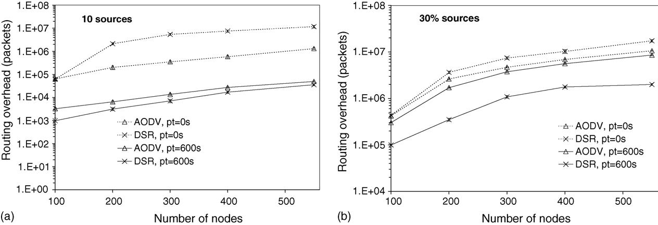

V. Naumov, T. Gross / Performance Evaluation 62 (2005) 193–209

197

Fig. 1. Routing overhead, in packets (100, 200, 300, 400, 550 nodes): 10 (a) and 30% (b) CBR trafﬁc sources. Log scale.

static (600 s pause time) scenarios. In the static scenarios with 10 CBR sources (Fig. 1a) both protocols
generate a moderate routing load that shows little (adequate) dependence on the number of nodes. DSR
produces around two times less load than AODV (the difference is more pronounced with low number
of nodes). With high mobility rate DSR quickly loses its superiority and already at 200 nodes sends an
order of magnitude more administrative packets than AODV. The reasons for such a behavior will be
analyzed in Section 4. With 30% of the nodes acting as CBR sources the ROP of both protocols increases
by 2 orders of magnitude (more with higher number of nodes). With 0 s pause time ROP for AODV is
50–100% lower than the ROP for DSR; whereas in stationary networks the situation is opposite, DSR
produces three to four times less administrative packets than AODV.
To summarize, DSR has a lower ROP than AODV in stationary scenarios (600 s pause time) and a
higher ROP in case of constant nodes motion. Results in ROB [14] take away some of DSR superiority
in stationary scenarios and increase the gap between the protocols in the dynamic scenarios.

3.1.2. PDF
In our experiments we analyze how the increasing number of nodes inﬂuences the performance of
both protocols. Fig. 2 depicts the PDF measured with 100, 200, 300, 400, 550 nodes for different trafﬁc
loads. In stationary scenarios (600 s pause time) with 10 CBR sources both protocols demonstrate good
scalability with respect to the increasing number of nodes (and increasing path length), with AODV
having a minor advantage over DSR at 400 and 550 nodes. With 0 s pause time performance of AODV
slowly degrades from 96% at 100 nodes to 70% at 550 nodes, whereas DSR falls off markedly at 200
nodes when only 10% of the data packets are delivered. For settings with more than 200 nodes, DSR
experiences signiﬁcant growth in ROP (Fig. 1) which prevents the protocol from functioning effectively.
However, both protocols experience difﬁculties in terms of PDF when every third node acts as a CBR
source (Fig. 2b). Even with 100 nodes and 600 s pause time AODV and DSR show only half the PDF
observed in the scenarios with 10 trafﬁc sources. As the number of nodes grows, the protocols PDF falls
quickly, and at 550 nodes only 6% of data packets ﬁnd their way to their destinations. The same picture
is observed with 0 s pause time—from initial 40% (AODV) and 28% (DSR) of delivered data packets at
100 nodes performance falls to 1–2% at 550 nodes.

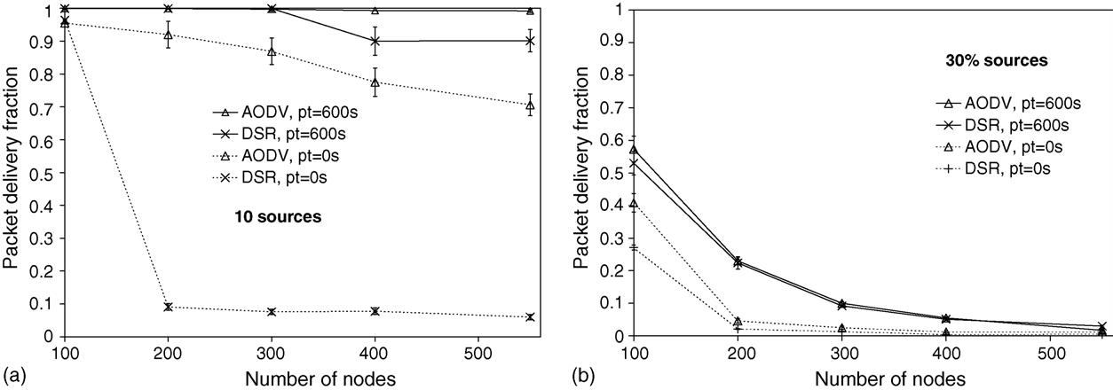
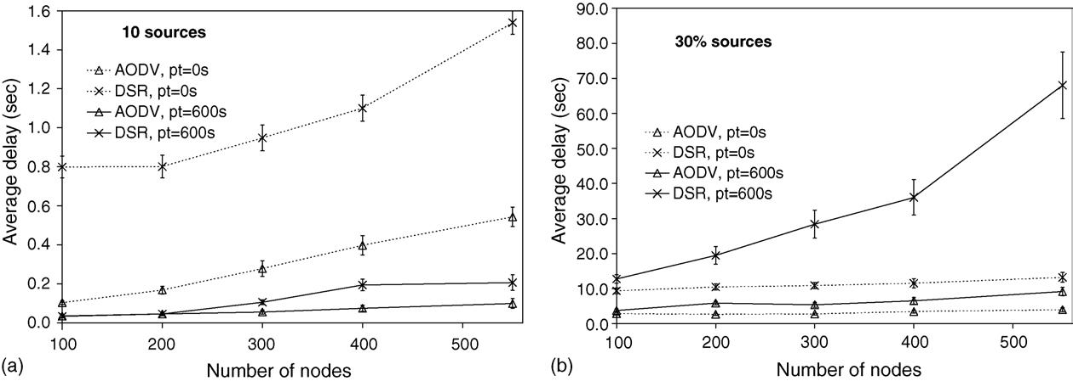

198

V. Naumov, T. Gross / Performance Evaluation 62 (2005) 193–209

Fig. 2. Fraction of packets sent that is delivered (PDF) (100, 200, 300, 400, 550 nodes): 10 and 30% CBR trafﬁc sources.

DSR caches all known routes; this strategy brings some improvements when the number of sources
is high and the mobility rate is low. It is very likely that during route discovery for some destination D
a route for another node A is found, recorded, and later used from the cache. But as the mobility rate
increases, the information in caches becomes quickly stale, and this feature of DSR does not contribute
signiﬁcantly. How the mobility rate inﬂuences the scalability of both protocols is studied in Section 3.2.

3.1.3. Delay
The best average end-to-end delay is exhibited by both protocols in those scenarios that performed
better according to the ROP and PDF metrics. With 10 CBR sources and 600 s pause time the delay for
AODV and DSR is below 0.2 s with any number of nodes (Fig. 3). But the two protocols react differently
to highly mobile hosts—the latency of AODV jumps up by 3–5 times, whereas DSR’s latency increases
8–20 times. These latencies demonstrate more noticeable dependence on the number of nodes than in the

Fig. 3. Average end-to-end data packet delay (100, 200, 300, 400, 550 nodes): 10 and 30% CBR trafﬁc sources. Note different
scales for (a) and (b).

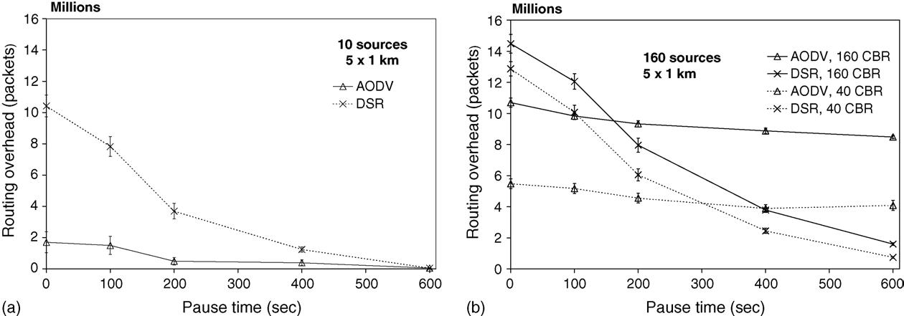

V. Naumov, T. Gross / Performance Evaluation 62 (2005) 193–209

199

stationary case. Since an increasing number of nodes in our experiments means also an increasing path
length, this behavior is easy to explain: longer routes takes longer time to discover and to travel along
them. They also have a higher probability to break than shorter ones; as a consequence more route repairs
are needed, which in turn result in a higher latency of the data packets.
With 30% of nodes acting as CBR sources AODV’s delay shows little dependence on the number of
nodes and varies from 2.9 to 9.2 s. DSR exhibits similar behavior with 0 s pause time. The delay grows
from around 10 s at 100 nodes to 13.3 s at 550. However, the delay of DSR in a stationary case grows
dramatically with the increasing number of nodes (from 13.5 s at 100 nodes to 68 s at 550 nodes). At
the ﬁrst glance there is an obvious contradiction with the default timeout value for a data packet (60 s).
In reality there is no mistake—this happens because data packets dropped at source nodes by the MAC
layer are re-inserted back into the send-buffer. The timeout is reset and the new route discovery is started,
leading to such an enormous latency of data packets. The negative inﬂuence of this behavior on the overall
performance of DSR will be described in Section 4.

3.2. Inﬂuence of mobility rate

For better understanding of how the rate of mobility and the number of trafﬁc sources affect protocols
performance we present the experimental results when the number of nodes in the scenarios is kept
constant (550 nodes on 5 km Ч 1 km area).

3.2.1. ROP and ROB
Fig. 4 depicts ROP as a function of both pause time and network load for different numbers of trafﬁc
sources (the graph for ROB is not presented here due to space limits, see [14]).
In the scenarios with 10 CBR sources and 0 s pause time, DSR is afﬂicted by an ROP that is six
times higher than AODV’s ROP. For both protocols the load decreases as the pause time grows and the
difference between the protocols disappears as the pause time reaches 600 s.
The situation changes when there are more trafﬁc sources, shown in Fig. 4b. AODV has a slight edge
over DSR for highly mobile setups, but at a pause time of 200 s for 160 CBR sources and 400 s for
40 CBR sources, the ROP of DSR becomes lower than for AODV. DSR continues to improve as the

Fig. 4. Routing overhead, in packets (550 nodes): 10, 40, and 160 CBR trafﬁc sources.

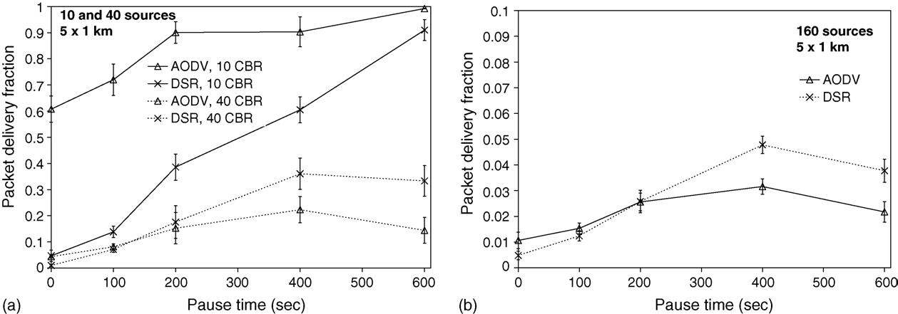

200

V. Naumov, T. Gross / Performance Evaluation 62 (2005) 193–209

Fig. 5. Fraction of packets sent that is delivered (PDF) (550 nodes): 10, 40 (a), and 160 (b) CBR trafﬁc sources. Note different
scale for (a) and (b).

pause time increases, whereas AODV stays more or less constant. We see that the incremental cost of
additional trafﬁc sources decreases as we add more sources. AODV demonstrates a higher dependence
on the number of CBR sources than DSR. DSR, in turn, is more dependent on the mobility rate.
According to the ROB metric, DSR is always more expensive than AODV, since DSR adds source routes
to administrative packets. For example, with 0 s pause time DSR transmits 1930, 2180, and 2300 MB
in the scenarios with 10, 40, and 160 trafﬁc sources. AODV sends 4 to 24 times less bytes: 80, 260,
and 510 MB in the corresponding scenarios. In the stationary networks (600 s pause time) both protocols
transmit similar amount of bytes: 13, 227, and 410 MB.
But although DSR transmits a signiﬁcantly larger number of bytes than AODV, the number of packets
transmitted by DSR is not always higher, and the overall cost does not follow directly the number of
bytes. Considering the high cost to access the medium, the cost to send a bigger number of small packets
is higher than sending a smaller number of larger packets. Fig. 5a and b (in the next section) revisit
this issue. Our data provide additional evidence: for the scenarios with 40 and 160 trafﬁc sources and
600 s pause time, both DSR and AODV have similar ROB, but AODV has a higher ROP. Since in these
scenarios DSR has a higher percentage of data packets delivered than AODV, sending the same payload
in fewer large packets is indeed costly.

3.2.2. PDF
Fig. 5 depicts the PDF measured with 550 nodes as a function of node mobility, for different numbers
of trafﬁc sources. With 10 CBR sources at 0 s pause time, AODV outperforms DSR (60% of the packets
are delivered versus 5% for DSR). DSR turns out to be unable to effectivly deliver data in a highly
dynamic network populated by a large number of nodes. The reason for this non-performance is the high
routing overhead of this protocol, as depicted in Fig. 4 of Section 3.2. The performance of DSR improves
more or less linearly as the pause time grows, and DSR manages to deliver 91% of the data packets in
stationary networks. AODV, along the same line, also improves and quickly gains a good performance
level; AODV delivers 91% of the packets already at 200 s pause time and reaches the level of 99% in
stationary networks.

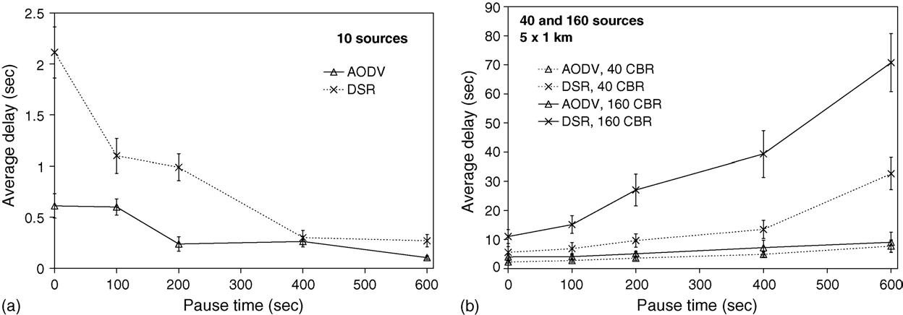

V. Naumov, T. Gross / Performance Evaluation 62 (2005) 193–209

201

However, the picture changes to the opposite with 40 CBR sources (Fig. 5a). AODV delivers from 5 to
50% fewer data packets than DSR for pause times over 200 s; up to 200 s, the protocols performance is
about the same. DSR delivers 33% of all packets that originate at a sender with 600 s pause time, whereas
AODV delivers only 16%. With 160 CBR sources, DSR also shows better performance than AODV once
the pause time is larger than 200 s. But this result is no cause for celebration; the network congestion
due to administrative packets is so high that both protocols loose from 97 to 99% of the data packets
(Fig. 5b).
As mentioned in Section 3.1.2, DSR caches all known routes; in the experiments with varying mobility
rates and different numbers of CBR sources, we see again that this strategy brings to DSR some improve-
ments when the number of sources is high and the mobility rate is low. In the highly mobile scenarios
with a big number of nodes a signiﬁcant amount of information is stored in the nodes caches, but it is
very difﬁcultly to proﬁt from this knowledge, since any stale entry only harms performance.

3.2.3. Delay
In all cases discussed so far, DSR has a higher average end-to-end data packet delay than AODV
(Fig. 6), although the average number of hops made by a delivered data packet stays lower for DSR than
for AODV (exact values for the number of hops can be found in [14]). DSR uses the length of a route as
the main criterion for choosing a route from several routes that are either returned by a route discovery or
stored in a node’s cache. AODV implicitly prefers the least congested routes, since it replies only to the
ﬁrst RREQ, ignoring the route length. That is the reason why AODV exhibits a slightly longer average
path, but shorter delays as will be shown in the next paragraphs.
Fig. 6 shows the data for the end-to-end delay. With 10 sources, the difference between the average
delay for DSR and AODV is about a factor of 4 (in favor of AODV) at 0 s pause time. AODV and DSR
both improve the average delay as the pause time increases. The delay caused by AODV slowly decreases
from 0.6 s at constant node motion toward 0.1 s for a stationary network. DSR approaches the delay for
AODV in the stationary case, but the delay remains about a factor 2 larger. This behavior corresponds
well to performance according to the ROP metric (with 10 CBR trafﬁc sources).

Fig. 6. Average end-to-end data packet delay (550 nodes): 10, 40, and 160 CBR trafﬁc sources. Note different scales for (a) and
(b).

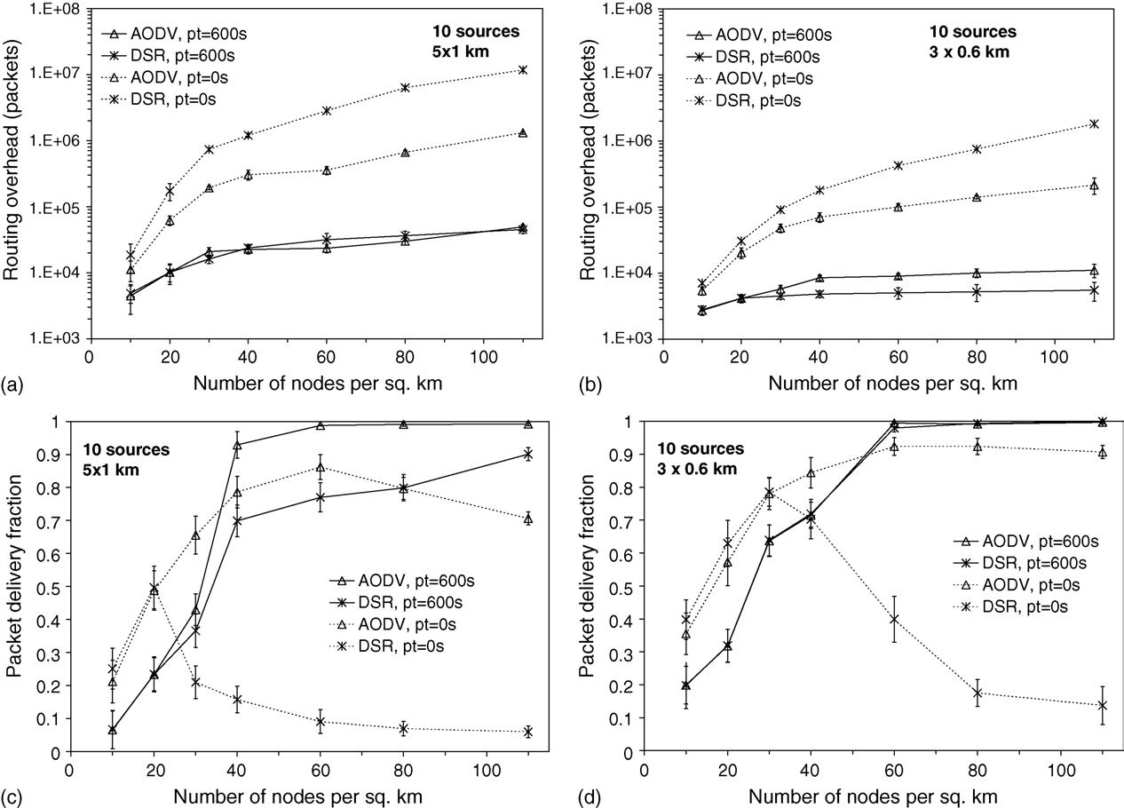

202

V. Naumov, T. Gross / Performance Evaluation 62 (2005) 193–209

Fig. 7. Inﬂuence of nodes’ density on the performance of protocols; 5 km Ч 1 km and 3 km Ч 0.6 km areas; different nodes
densities.

With 40 and 160 CBR sources, we observe a different picture—the delay increases with growing pause
time. This behavior can be explained with the contention in heavily loaded networks (see the previous
section for ﬁgures). Both protocols deliver a higher percentage of data packets at 600 s of pause time
than in scenarios with constant node motion, exploiting long paths as well as short ones, whereas in
highly mobile scenarios, most successful transmissions involve short paths. The reason is that long paths
have a high probability that a route will fail due to some node’s movement during the propagation of
a data packet. Since a data packet’s delay is directly proportional to the number of hops in its route to
a destination, the average delay increases when more long (stable!) paths are involved in a simulation.
We do not observe this behavior with 10 trafﬁc sources, since the congestion in stationary networks is
negligible (around 10–100 times lower), compared to one in highly dynamic environments.
Again, AODV demonstrates a more stable behavior—the average end-to-end delay grows slowly with
increasing pause time, whereas delays shown by DSR raise much more quickly and reach the value of
68 s with 160 CBR sources. The enormous increase of the DSR’s delay is the result of the resurrection
of data packets at source nodes, when the MAC transmission failed, as described in Section 3.1.

V. Naumov, T. Gross / Performance Evaluation 62 (2005) 193–209

3.3. Inﬂuence of density of nodes

203

The density of hosts should have a signiﬁcant inﬂuence on the routing protocols performance. Low
density may cause the network to be frequently disconnected. High density increases the contention,
resulting in a low per-node throughput. Earlier studies try to ﬁnd the optimal density of nodes [15,17,16].
Here we show how the density of nodes inﬂuences the performance of AODV and DSR in the areas
of 5000 km Ч 1000 km and 3000 m Ч 600 m. We simulate 10 CBR sources in the population of nodes,
varying their density from 10 to 110 nodes/km², which corresponds approximately to 2–20 neighbors
per node with our hardware parameters.
Fig. 7 presents ROP and PDF metrics for both protocols in two different areas as a function of nodes
density. In highly mobile scenarios (0 s pause time) AODV clearly outperforms DSR in both metrics and
exhibits good scalability. Both protocols deliver low percentage of data packets in the scenarios with
low nodes density—the result of frequently disconnected network. As the density increases, connectivity
improves and PDF of both protocols grows. However at around 20–30 nodes/km²DSR gets afﬂicted
by the high ROP, which leads to the performance degradation. AODV in turn beneﬁts further from the
increasing density of nodes and reaches its performance maximum at around 60–80 nodes/km². In the
static networks both protocols show similar behavior in ROP and PDF. The difference is more pronounced
in the 5000 m Ч 1000 m area, where the routes are longer. In 3000 m Ч 600 m area DSR has three to four
times lower ROP, but similar ROB. Average end-to-end delay stays higher for DSR in the scenarios with
0s pause time; in the static networks both protocols demonstrate similar delays (the graphs for ROB and
average delay are presented in [14]).
In general, AODV shows good scalability to different densities of nodes and area sizes, especially in
a highly mobile scenarios, whereas DSR shows good results only in small areas and only with the low
mobility of nodes.

4. Analysis of the experimental results

To obtain a better understanding of the causes for the poor performance demonstrated by both protocols,
we analyze more details of the network and summarize the problems observed. We also want to stress, that
the metrics presented above capture the performance of a protocol. But they do not reveal the problems,
that cause protocols poor performance. Thus, a researcher suggesting or evaluating some routing method
should look at other metrics that we introduce and discuss in detail in the next subsections.

4.1. Reasons behind low PDF

Our experiments show that with a low trafﬁc load (10 CBR sources) most of AODV data packets are
dropped at intermediate nodes (75–80%); the number of nodes and the rate of mobility vary the results
signiﬁcantly. However, DSR has a different tendency, dropping 90% of packets at intermediate nodes
with 100 nodes simulated, but from 200 to 550 nodes only 10–18% of the data packets are dropped at
intermediate nodes. The mobility rate also has some inﬂuence on this factor, but this inﬂuence is much
less pronounced.
DSR’s resurrection of failed data packets at source nodes does not only cause very high data packets
delays, it also forces more frequent route discoveries, which load the network. At the same time there is a

204

V. Naumov, T. Gross / Performance Evaluation 62 (2005) 193–209

certain inconsistency in this behavior. Why does a routing agent decide for a higher-level protocol which
packets should be retransmitted? There can easily be the case, when such a delayed data packet ﬁnally
reaches the destination, that it is either no longer needed, or was already retransmitted by the upper-level
protocol. When a data packet is dropped at a source node, no RERR packets need to be generated, and
it is logical to simply inform the upper-layer protocol about the problem and let it decide whether to
retransmit the packet or not. According to our experiments, when the automatic retransmission of a failed
data packet is switched off, the PDF of DSR improves in all the scenarios and the average end-to-end
delay decreases by up to 60%.
To summarize, in low trafﬁc load scenarios the majority of AODV data packets are dropped at interme-
diate nodes, although this number is small. DSR drops most of its data packets at intermediate nodes only
in the scenario with 100 nodes. The main reasons for both protocols to drop data packets are failed ARP
and MAC callback. As the number of trafﬁc sources increases, up to 99% of data packets are dropped
at source nodes. The cause for such a high number of drops at source nodes is the heavily congested
network, ﬂooded by administrative packets, which have higher priority in queues than data packets.
We observed that address resolution protocol (ARP) induces noticeable load on the network and
becomes a reason for dropping different types of packets. In the scenarios with high trafﬁc load up to
22% of the data packets and up to 27% of the administrative packets are dropped by ARP. The question
is if ARP is needed at all. In Section 5 we pursue this question in depth.

4.2. Reasons behind high administrative load

To analyze the reasons for high administrative load (especially of DSR) we compare several metrics:

(1) how many neighbors successfully receive a broadcast RREQ;
(2) what is the percentage of successful RREP transmissions;
(3) what is the percentage of successful data packet transmissions;
(4) what makes a difference in protocols performance.

The ﬁrst three metrics reﬂect the level of network load and help to understand the reasons for a low PDF.
The forth one emphasizes how the different routing strategies of AODV and DSR affect their performance.
Here we report the result only when 10 trafﬁc sources are used, since only in this case the performance of
one protocol is good (acceptable). Analysis of this setup allows us to draw conclusions on which routing
strategy is better and why. With higher number of sources the performance of both protocols becomes
equally poor, which makes it less interesting to compare.

4.2.1. Successful RREQ transmissions
The known problem is that many of the packets sent by a routing layer of a node are consequently
dropped due to MAC collisions. RREQ packets are the foundation of route discovery. If a high percentage
of a node’s neighbors are not able to capture an RREQ broadcast, then there is a high probability that this
discovery will fail, waisting network capacity and delaying data packets.
To understand the success of the route discovery of both protocols, we analyze the following metric.
Table 1 shows the ratio of the total number of RREQ packets that were successfully received by the

Table 1

V. Naumov, T. Gross / Performance Evaluation 62 (2005) 193–209

205

Ratio of RREQ packets received to the number of RREQ transmissions, as a function of number of nodes

Protocol

AODV
DSR
Number of nodes
100
16.4
17.7

200
16.8
7.4

300
16.9
3.9

400
17.4
3.5

550
17.4
3.14

protocol to the total number of RREQ transmissions, as a function of number of nodes,⁵We see that
exactly in the scenarios where DSR has shown poor PDF, only around 3–7 nodes successfully receive a
RREQ broadcast packet. In our experiments, the number of a node’s neighbors vary from around 10 to
around 21, depending on the position of a node and the size of the area used. So most of a node’s neighbors
cannot capture the RREQ packet because of collisions with some other concurrent transmissions, mostly
other broadcasts (hidden terminal problem). AODV drops 5–10% of RREQ transmissions, whereas DSR
drops from 1% at 100 nodes to 79% at 550 nodes. With such a drop rate of DSR it is very hard to
successfully discover a route. But even if one-way route is found, an RREP packet still has to propagate
back to the initiator of the route discovery.

4.2.2. Successful RREP and data transmissions
We use the following logic to estimate the success of a unicast transmission. Each send or forward
event of a unicast packet should be followed by a receive event, provided the transmission was successful,
otherwise the packet is dropped. We count the total number of successfully received unicast packets
packets and normalize it by the number of sent and forwarded unicast packets. In the ideal case this ratio
must be 1.00 (or 100%), but in reality, it is of course lower. Table 2 reveals the issue. AODV manages
to deliver the majority of RREP answers back to sources and, consequently, the majority of data packets
to their destinations. However, in the case of DSR only 6–21% of RREP one-hop transmissions are
successful, and every second one-hop transmission of a data packets fails.

4.2.3. Analysis of routing strategy
AODV and DSR are both reactive protocols that share the same route discovery strategy. However,
different approaches in maintaining the routes and in storing routing information lead to different perfor-
mance results. Here we are trying to analyze the reasons that cause high administrative load.
To establish a route both protocols broadcast RREQ packets that propagate through the network. If a
route breaks, the protocols have the possibility to ﬁx a broken route without starting a new route discovery
from a source. We analyze how many RREQ are generated by source nodes and other (intermediate) nodes.
Intermediate node may generate an RREQ in case of a local route repair (AODV) or of packet salvaging
(DSR).
Table 3 shows the number of RREQ packets that were generated on average by each source node and
each intermediate node in different scenarios. Switching from the 100 nodes to the 200 nodes scenario,
DSR experiences a boost in the number of RREQ generated for each source and intermediate node.
Exactly in this scenario DSR starts experiencing performance problems that continue as the number of

5 For simplicity, in the rest of this paper we use only the number of nodes to represent a scenario. Section 1 contains the
complete description of all scenarios.

206

Table 2

V. Naumov, T. Gross / Performance Evaluation 62 (2005) 193–209

Ratio (%) of RREP and data packets received to the number of RREP and data transmissions, as a function of number of nodes

No. of nodes

100
200
300
400
550

Table 3
AODV
RREP
0.96
0.95
0.95
0.94
0.93

Data
0.98
0.98
0.98
0.97
0.96
DSR
RREP
0.76
0.21
0.10
0.08
0.06

Data
0.99
0.50
0.47
0.46
0.39

The number of RREQ packets that an average source and intermediate node sends, as a function of number of nodes

No. of nodes

100
200
300
400
550
AODV
Source
93
132
146
215
254

Intermediate
3
3
2
2
2
DSR
Source
20
484
1635
2124
3179

Intermediate
10
465
1586
2198
2797

nodes grows. Intermediate DSR nodes generate approximately as many RREQ packets as source nodes,
which speaks for frequent route repair attempts. Physically the routes do not break for DSR more often
than for AODV, the high level of congestion makes DSR believe that the next hop node is gone, because
it did not respond with the CTS or did not acknowledge the reception of a unicast packet.
A logical continuation of an RREQ is RREP. An RREQ storm of DSR is followed by RREP storm—
DSR sends 10 (with 100 nodes) to 100 (with 550 nodes) times more RREP than AODV. DSR replies to
all RREQ creating an additional load by RREP packets on the ﬁrst step. Since in our experiments every
node has from 10 to 21 neighbors on average, each route discovery (RD) process will obtain up to 21
different routes to a destination. Of course not all of them will be valid long enough to serve as a backup
path for the currently chosen one. If a route breaks, DSR may (and usually does) take another route from
the cache. But there is no guarantee a newly chosen route will lead a data packet to the destination. If
the route is stale, a new RD is performed, increasing the network congestion. The aggressive use of the
cached routing information forces a lot of intermediate nodes to reply to a source of the route discovery.
In the end the source node receives a high number of different paths, and consequently it is difﬁcult to
choose the best one. As Table 2 reports, the majority of DSR RREP packets are dropped, so they only
waste the network capacity. Thus, when the number of highly mobile nodes is large, gathering a lot of
routing information may work against a protocol, as we see in the case of DSR.

5. A new look on ARP

As we mentioned in Section 4.2, many routing (unicast) and data packets are dropped due to failed ARP.
Here we study this problem and suggest a new revised ARP for wireless ad hoc networks. In computer

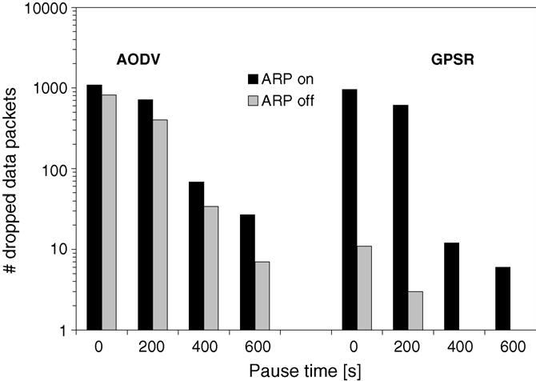

V. Naumov, T. Gross / Performance Evaluation 62 (2005) 193–209

207

networking using the internet protocol suite, the Address Resolution Protocol is a method for ﬁnding
a host’s physical address (MAC address), given its IP address. The sender broadcasts an ARP packet
containing the Internet address of another host and waits for it (or some other host) to send back its MAC
address. Each host maintains a cache of address translations to reduce delay and loading. To meet the
needs of different types of local area network, there are separate ARP speciﬁcations for Ethernet, Frame
Relay, ATM, Fiber Distributed-D ata Interface, HIPPI, etc.
In mobile ad hoc networks with the large number of hosts, a lot of transmissions have to wait until ARP
resolves IP to MAC correspondence, since a node’s neighborhood changes constantly. In the worst case
in the network with n mobile hosts O(n · (n − 1)) ARP sessions are needed, since for each pair of hosts
there must be two ARP exchanges performed. As all wireless transmissions, ARP packets are subject to
collisions, which delay data or routing packet transmissions and may (and often do) lead to packet drops.
At the same time a host A, before sending a unicast message to another host B, must ﬁrst receive any
packet from B. Thus the ARP-exchange becomes simply obsolete.
There are many ways how we can avoid unnecessary ARP exchanges and still maintain compatibility
with systems that rely on ARP. One approach is to use cross-layer feedback. For every packet received,
the MAC protocol (Data-link layer) provides IP to MAC address mapping to the ARP protocol (Network
layer). The ARP protocol still maintains the cache and adds MAC addresses for outgoing IP packets. If
there is no entry in the cache, ARP may use its standard exchange and obtain MAC address of the next
hop destination traditionally. Another approach is to add a ﬁeld for MAC address to IP packet header,
e.g., to Options ﬁeld. ARP can be used to add/extract MAC address from IP packets.
To determine the performance gain by omitting the ARP exchange we have conducted several ex-
periments with AODV and GPSR (greedy perimeter stateless routing) protocol [9]. For both protocols
we run simulations with standard ARP and a modiﬁed ARP, when MAC addresses are added to the IP
packet. We took AODV as a representative of broadcast-based routing protocols, since it has shown better
performance results than DSR. With DSR it would be difﬁcult to estimate the inﬂuence of a new ARP,
since DSR suffers more than AODV from a high administrative load imposed by RREQs. GPSR is one
of the well-recognized geographic routing protocols, showing good performance [9]. A unicast packet

Fig. 8. Number of data packets dropped by AODV and GPSR as a function of pause time. “ARP on”—standard ARP is used.
“ARP off”—revised ARP version is used. Ten CBR sources.

208

V. Naumov, T. Gross / Performance Evaluation 62 (2005) 193–209

needs an ARP exchange if the MAC address of the packet destination is not known. Another reason for
choosing GPSR is to test the following assumption: a protocol that operates mostly with unicast packets
should beneﬁt more from omitting ARP exchange. Thus, GPSR should reduce the number of drops more
signiﬁcantly than, e.g., AODV.
Fig. 8 shows the number of data packets dropped by both protocols in the scenarios with 10 CBR
sources (please note that a logarithmic scale is used). We simulate both standard ARP exchange “ARP
on” and revised ARP “ARP off”. We see that both protocols drop signiﬁcantly fewer data packets when
no ARP exchange is used. As the mobility of nodes increases (the pause time becomes smaller), a node’s
neighborhood changes more frequently, requiring more frequent ARP exchanges. As a result many data
packets are dropped due to ARP failure. Omitting the ARP exchange saves a lot of them. This phenomena
is more pronounced with GPSR, since it relies mostly on unicast transmissions. That result supports our
hypothesis that a unicast protocol beneﬁts more from changes to the ARP exchange.

6. Concluding remarks

We looked in detail at different aspects that affect the scalability of two ad hoc routing proto-
cols, AODV and DSR. We analyzed how the performance of AODV and DSR depends on the area,
the number of nodes, the density of nodes, the rate of node mobility, and the suggested data trafﬁc
load.
In stationary scenarios with a low number of trafﬁc sources both protocols demonstrate good scalability
with respect to the number and density of nodes. But as the mobility rate (and/or density of hosts) increases,
the routing overhead of DSR precludes this protocol from delivering data packets effectively. The attempts
to limit the routing load by aggressive use of the cached routing information results in a higher number of
administrative packets. This factor seems to limit the scalability of DSR and there may be an opportunity
to change to the way DSR builds up and uses cached information, by adding some optimizations, e.g.,
like suggested in [18].
The poor results shown by both protocols in the scenarios with high trafﬁc load suggest that effective
strategies to eliminate the load of simple RREQ ﬂooding should be adopted by both protocols to improve
their scalability. We also point that traditionally considered metrics do not uncover all the sources of
protocol performance problems. We suggested and discussed additional metrics that help to understand
the issue.
The suggested revised role of ARP in wireless ad hoc network simpliﬁes communication between
hosts and improves the performance of any routing protocol, especially in scenarios with high mobility
of hosts.
Ad hoc networks show a lot of promise to extend the reach of the world of managed networks. But
before ad hoc networks become widely used, it is necessary to improve their scaling behavior.

Acknowledgements

This research was supported, in part, by the NCCR “Mobile Information and Communication Systems”,
a research program of the Swiss National Science Foundation, and by a gift from the Microprocessor
Research Lab (MRL) of Intel Corp.




References

V. Naumov, T. Gross / Performance Evaluation 62 (2005) 193–209

209

[1] Wireless LAN medium access control (MAC) and physical layer (PHY) speciﬁcations, IEEE Standard 802.11, Technical
report, 1999.
[2] J. Broch, D. Maltz, D. Johnson, Y. Hu, J. Jetcheva, A performance comparison of multi-hop wireless ad hoc network routing
protocols, Proceedings of the MOBICOM’98, 1998, pp. 85–97.
[3] S. Das, Ch. Perkins, E. Royer, Performance comparison of two on-demand routing protocols for ad hoc networks, Proceed-
ings of the INFOCOM’00, 2000, pp. 3–12.
[4] K. Fall, Ns notes and documentation, The VINT Project, 2000.
[5] M. Gastpar, M. Vetterli, On the capacity of wireless networks: the relay case, Proceedings of the INFOCOM’02, 2002.
[6] P. Gupta, P. Kumar, The capacity of wireless networks, IEEE Trans. Inform. Theory 46 (2000) 388–404.
[7] P. Johanson, T. Larsson, N. Hedman, B. Mielczare, M. Degermark, Scenario-based performance analysis of routing protocols
for mobile ad-hoc networks, Proceedings of the MOBICOM’99, 1999, pp. 195–206.
[8] D. Johnson, Validation of wireless and mobile network models and simulation, DARPA/NIST NSV Workshop, 1999.
[9] B. Karp, H. Kung, GPSR: greedy perimeter stateless routing for wireless networks, Proceedings of the MOBICOM’00,
2000, pp. 243–254.
[10] V. Naoumov, Th. Gross, Simulation of large ad hoc networks, Proceedings of the MSWiM’03, 2003, pp. 50–57.
[11] Ch. Perkins, E. Royer, Ad-hoc on-demand distance vector routing, Proceedings of the WMCSA’99, 1999, pp. 90–100.
[12] E. Royer, S-J. Lee, Ch. Perkins, Ad hoc on-demand distance-vector routing scalability, ACM MCC Rev. 6 (2002) 94–95.
[13] J. Li, C. Blake, D. De Couto, H. Lee, R. Morris, Capacity of ad hoc wireless networks, Proceedings of the MOBICOM’01,
2001, pp. 61–69.
[14] V. Naumov, Th. Gross, Scalability of routing methods in ad hoc networks, Internal technical report, 2005.
http://www.lst.inf.ethz.ch/research/publications.
[15] L. Kleinrock, J. Silvester, Optimum transmission radii for packet radio networks or why six is a magic number, IEEE NTC
(1978) 4.3.1–4.3.5.
[16] F. Xue1, P.R. Kumar, The number of neighbors needed for connectivity of wireless networks, Wireless Networks 10 (2)
(2004) 169–181.
[17] E. Royer, P. Melliar-Smith, L. Moser, An analysis of the optimum node density for ad hoc mobile networks, IEEE ICC
(2001).
[18] M. Marina, S Das, Performance of route caching strategies in dynamic source routing, Proceedings of the ICDCSW, vol.
00, 2001, p. 0425.

Valery Naumov received a Master of Science in Physics/Computer Science from Novosibirsk State Uni-
versity (Russia) in 1999. In July 2000 he started his PhD at Computer Systems Institute of Swiss Federal
Institute of Technology in Zurich, Switzerland.

Thomas Gross joined CMU in 1984 after receiving a PhD in Electrical Engineering from Stanford Univer-
sity. In 2000, he became a Full Professor at ETH Zurich, Switzerland. He is now the head of the Computer
Systems Institute, from 1999 to 2004 he was the deputy director of the NCCR on “Mobile Information and
Communication Systems", a research center funded by the Swiss National Science Foundation. He is also
an Adjunct Professor in the School of Computer Science at Carnegie Mellon University.

